Second Partial Exam. TC2026: Web Applications Development. Jul-Aug 2020  
  
NAME: [ Jesus Javier Lozano Martinez ]  
GITHUB REPOSITORY: [**PASTE HERE YOUR GITHUB REPOSITORY**]

Instructions:

* You must have your webcam turned on.
* **Turn off your cellphone and close any social media site.**
* You are allowed to use the following during the exam:
  + Command line / Terminal / Gitbash.
  + The editor of your preference to write the coding solutions.
  + Material from class is allowed.
* Code everything from zero.
* When you finish the exam, you will need to upload to CANVAS this file.
* You cannot ask any classmate for anything. This exam is a test of how much you have learned.

**Part 1 - Express**

1. Create file called “server.js” and write all necessary code to have a node-express server which runs on port 5000. (Don’t forget to initialize your project).
2. Create the following routes using the necessary types of http requests. You must include a screenshot of each request with the corresponding response using any of: Postman, Rest Client, Insomnia.  
   1. ***GET*** *listening on url: “/” which replies to the client a text: “You are on the homepage”.*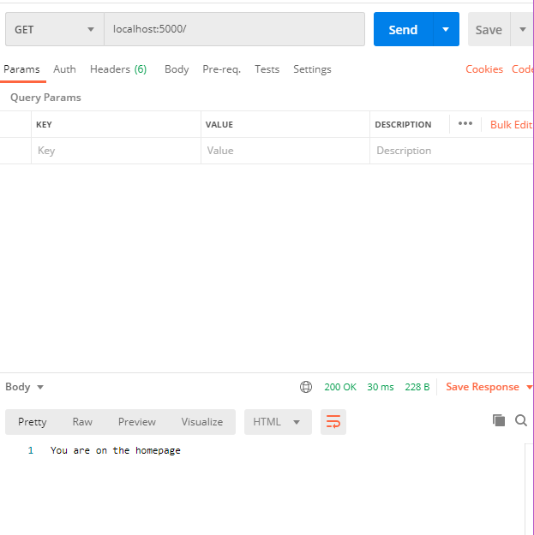
   2. ***POST*** *listening on url: “/post” which must send to the server a json object with**the following fields:* ***user, password.***

*Send a request (with random data) and reply back to the user “Welcome {user}” (where user must be the value sent in the request).* ***HINT:*** *You need to include a middleware so the server understands the json data it is receiving.*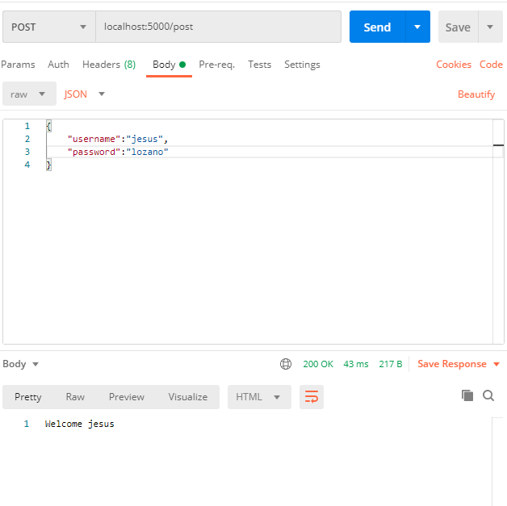

* 1. ***DELETE*** listening on url: “/delete” which must send a json object with the following field: **taskId**

Send a request with a **taskId** and reply back to the user: “{delete: true}”  
  
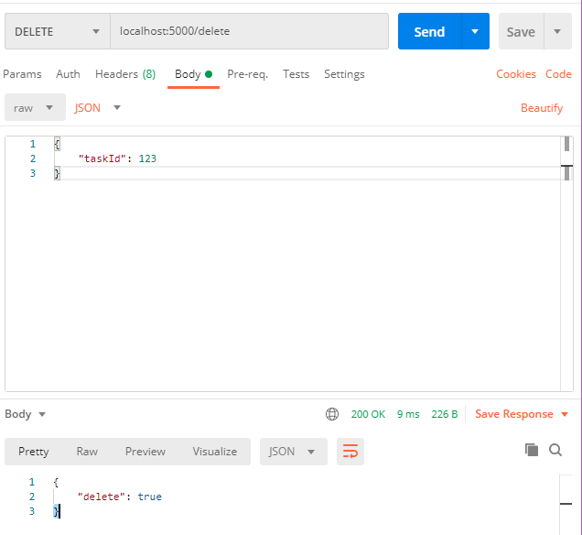

* 1. ***PUT*** listening on url “/put/**{ID}**” which does not send anything in the body.

Send a request like: “/put/123 and reply back to the user: “Task 123 has been updated”  
  
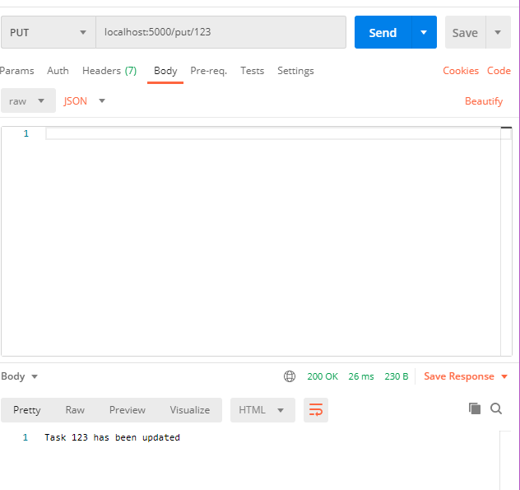

After you are done create a new github repository and upload your project. Be sure to paste your github repo in the top of this file.

**Part 2** – **Mongo**

In this section you need to write the requested queries. You must attach a screenshot that contains the query and the result of each query. If you have issues with your local MongoDB , you can use the following web-shell:   
<https://docs.mongodb.com/manual/tutorial/getting-started/>

1. Write a query to: Create a Database called: **web-store**
2. Write a query to: Create a Collection called: **products**
3. Write a query to: show the list of available collections.
4. Write a query to insert a document to a Collection with the following fields/data:

name: “shoes”

cost: 199.99

stock: 10

date_added: [current Date]

1. Write a query that: shows all available products in the **products** Collection.
2. Add a second document to the **products** Collection with the following data:

name: “sun-glasses”

cost: 500

stock: 2

1. Write a query that: shows all available products in the **products** Collection using the “pretty” mode.
2. Write a query to update the “stock” of the “sun-glasses” from the current stock to 20. Also write another query to show that the update worked showing the new stock. (In total here 2 queries)
3. Write a query to delete product with name “shoes” and also write a query to visualize that the product is no longer present. (In total here 2 queries)
4. Write a query to drop the current database.

“If you try and Fail, Congratulations.

Most People won’t even try”